Practical No:-4
Create a Simple REST Service to demonstrate CRUD operations with “Product” database. Implement the service with fields viz. Product_Name, Quantity, Expiry_date. Deploy the service and Execute the operations.

Step1: Create a datbase and table
mysql> create database productdb_sufyan6111;
mysql> use productdb_sufyan6111;
mysql> create table Product(
product_name varchar(50),
quantity int,
expiry_date date
);
mysql> show tables;
mysql> desc Product;
mysql> select * from Product;
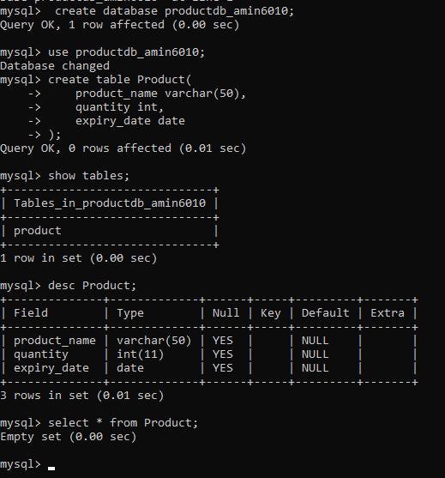
- Insert Data
package ServerPackage;
import javax.ws.rs.core.Context;
import javax.ws.rs.core.UriInfo;
import javax.ws.rs.Produces;
import javax.ws.rs.Consumes;
import javax.ws.rs.GET;
import javax.ws.rs.Path;
import javax.ws.rs.PUT;
import javax.ws.rs.core.MediaType;
import java.sql.*;
@Path("generic")
public class GenericResource {
@Context
private UriInfo context;

public GenericResource() {
}
@GET
@Produces(MediaType.APPLICATION_XML)
public String getXml() {
//TODO return proper representation object
throw new UnsupportedOperationException();
}
@PUT
@Consumes(MediaType.APPLICATION_XML)
public void putXml(String content) {
}
@PUT
@Consumes(MediaType.APPLICATION_XML)
@Path("/ExecuterQuery")
public String executeMyquery(String query)
{
try
{
Class.forName("com.mysql.jdbc.Driver");
String url = "jdbc:mysql://localhost/productdb_awaiz6013";
Connection con = DriverManager.getConnection(url,"root","maha");
Statement st = con.createStatement();
String q = query;
st.execute(q);
st.close();
con.close();
return "Query is Executed!!!";
}
catch (Exception e)
{
return e.getMessage();
}}
}
Output:-
Insert Query
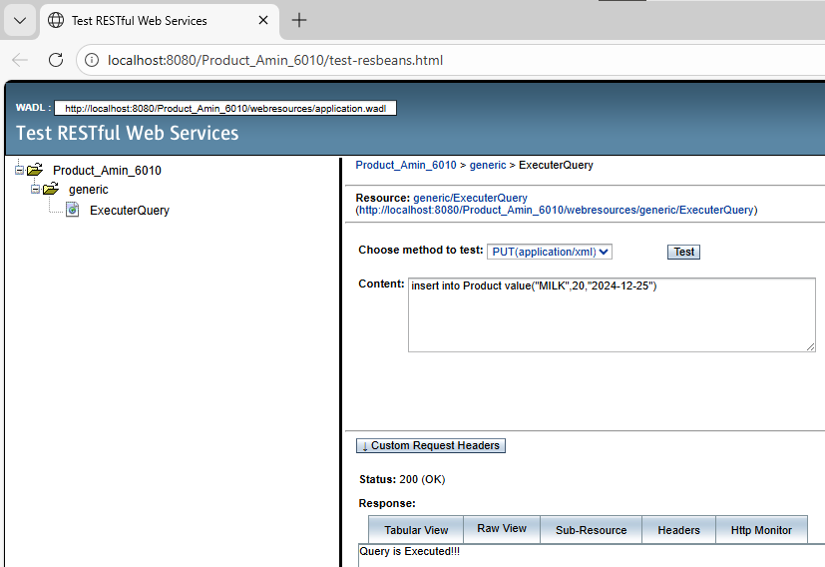

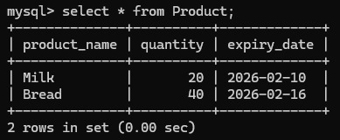

Update Query

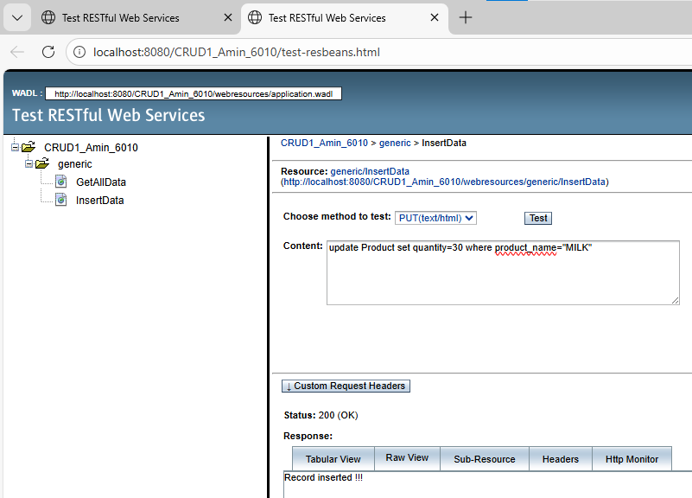

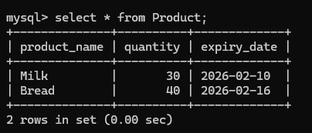

Delete Query
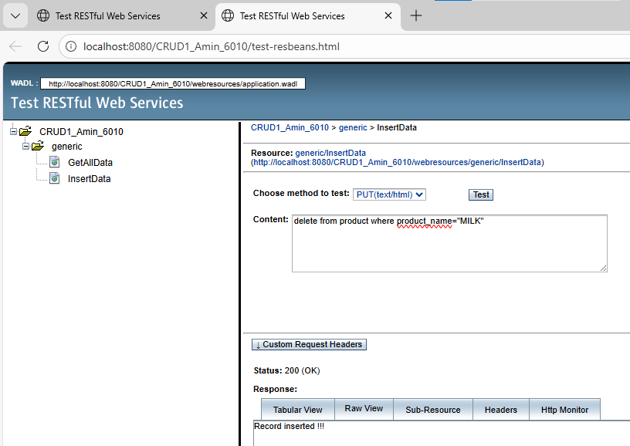

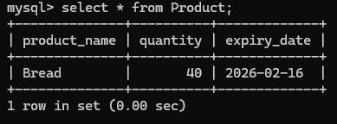

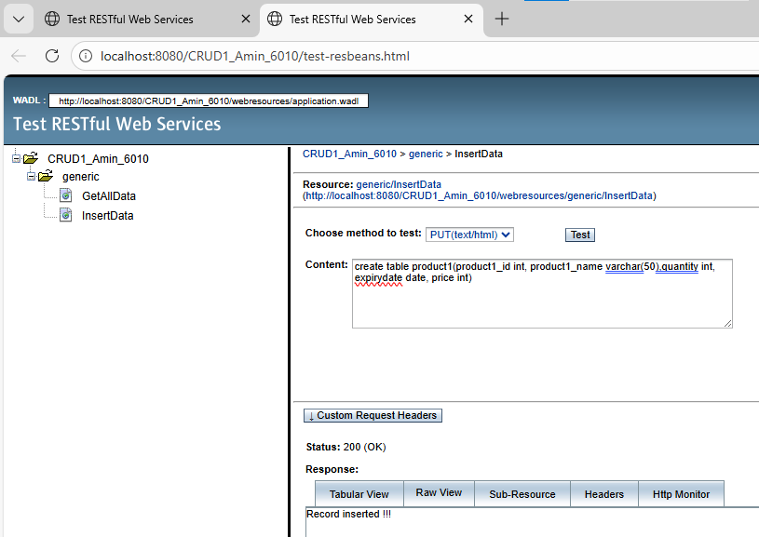

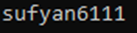
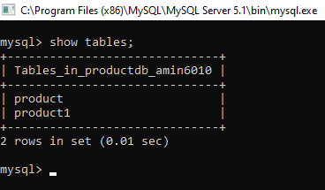
- Retrieve all records

Code:

package ServerPackage;

import javax.ws.rs.core.Context;
import javax.ws.rs.core.UriInfo;
import javax.ws.rs.Produces;
import javax.ws.rs.Consumes;
import javax.ws.rs.GET;
import javax.ws.rs.Path;
import javax.ws.rs.PUT;
import javax.ws.rs.core.MediaType;

import java.sql.*;

@Path("generic")
public class GenericResource {

@Context
private UriInfo context;

public GenericResource() {
}

@GET
@Produces(MediaType.APPLICATION_XML)
public String getXml() {
//TODO return proper representation object
throw new UnsupportedOperationException();
}

@PUT
@Consumes(MediaType.APPLICATION_XML)
public void putXml(String content) {
}

@PUT
@Consumes(MediaType.APPLICATION_XML)
@Path("/ExecuterQuery")
public String executeMyquery(String query)
{
try
{
Class.forName("com.mysql.jdbc.Driver");

String url = "jdbc:mysql://localhost/productdb_awaiz6013";
Connection con = DriverManager.getConnection(url,"root","maha");

Statement st = con.createStatement();
String q = query;

st.execute(q);

st.close();
con.close();

return "Query is Executed!!!";

}
catch (Exception e)
{
return e.getMessage();

}
}

@PUT
@Consumes(MediaType.APPLICATION_XML)
@Path("/GetAllProduct1")
public String GetAllProduct1(String query)
{
try
{
Class.forName("com.mysql.jdbc.Driver");

String url = "jdbc:mysql://localhost/productdb_awaiz6013";
Connection con = DriverManager.getConnection(url,"root","maha");

Statement st = con.createStatement();
String q = query;

String data ="";

ResultSet rs = st.executeQuery(q);

while(rs.next())
{
data = data + rs.getString(1) +" ";
data = data + rs.getString(2) +" ";
data = data + rs.getString(3) +" ";

}

st.close();
con.close();

return data;

}
catch (Exception e)
{
return e.getMessage();

}
}
}
OUTPUT:-
